***Name : HIMANSHU DIXIT***

***Enrollment Number: B64178***

***Batch: B10***

***Experiment No : 5***

***(MALUS LAW)***

***Aim:***

To verify the Malus law .

***Formula Used:***

|  |
| --- |
| I = Io cos^2X |

Where,

I → is intensity of the light transmitted by the analyser.

Io → is intensity of the light incident on the analyser.

X → is angle between the pass axes of the analyser & polariser.

***Obesevation table:***

|  |  |
| --- | --- |
| ***Angle(degree)*** | ***Intensity(mA)*** |
| 0 | 10 |
| 10 | 9.70 |
| 20 | 8.83 |
| 30 | 7.53 |
| 40 | 5.87 |
| 50 | 4.13 |
| 60 | 2.50 |
| 70 | 1.17 |
| 80 | 0.30 |
| 90 | 0 |
| 100 | 0.30 |
| 110 | 1.17 |
| 120 | 2.50 |
| 130 | 4.13 |
| 140 | 5.87 |
| 150 | 7.50 |
| 160 | 8.83 |
| 170 | 9.70 |
| 180 | 10 |
| 190 | 9.70 |
| 200 | 8.83 |
| 210 | 7.50 |
| 220 | 5.87 |
| 230 | 4.13 |
| 240 | 2.50 |
| 250 | 1.17 |
| 260 | 0.30 |
| 270 | 0 |
| 280 | 0.30 |
| 290 | 1.17 |
| 300 | 2.50 |
| 310 | 4.13 |
| 320 | 5.87 |
| 330 | 7.50 |
| 340 | 8.83 |
| 350 | 9.70 |
| 360 | 10 |

***Graph:***

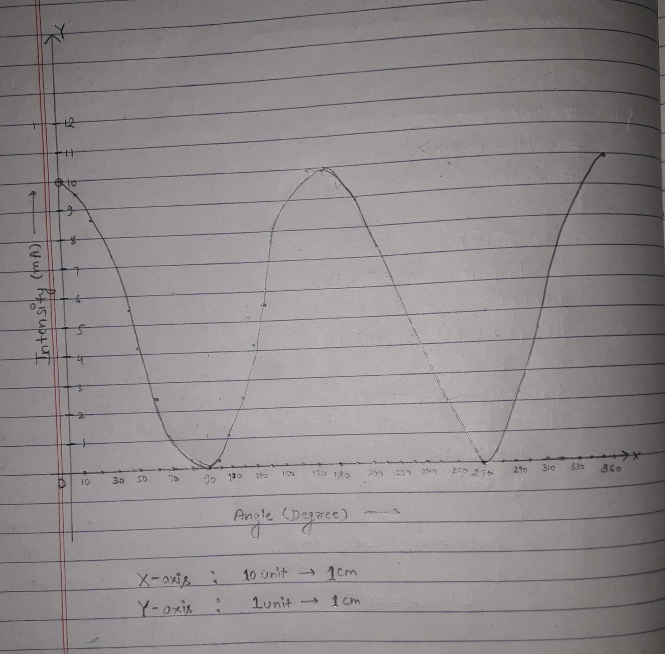

***Result:***

From the graph, I is directly proportional to cos^2X . hence, I=IoCos^2X

i.e.,Malus law is proved.

